19. Give 10% salary hike to ‘cse’ dept employees

UPDATE EMPOLY

SET SALARY=SALARY+0.1*SALARY

WHERE DEPT='QAS';

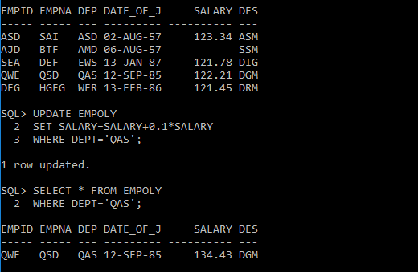

20. Delete ‘ece’ dept employees

DELETE FROM EMPOLY

WHERE DEPT='WER';

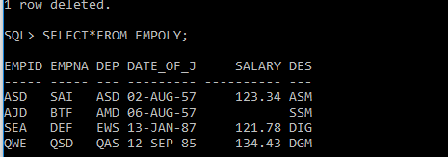

21. Copy the emp table contents to employee and employee1

FIRST CREATING TABLES

CREATE TABLE EMPLEEY(

EMPID VARCHAR(5),

EMPNAME VARCHAR(5),

DEPT VARCHAR(3),

DATE_OF_JOIN DATE,

SALARY NUMBER(5,2),

DESIGNATION CHAR(3));

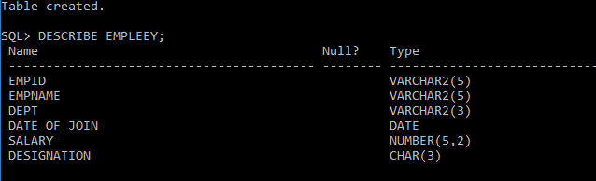

INSERT INTO EMPLEEY

SELECT *

FROM EMPOLY;

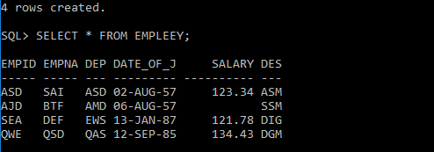

CREATE TABLE EMPLOYE(

EMPID VARCHAR(5),

EMPNAME VARCHAR(5),

DEPT VARCHAR(3),

DATE_OF_JOIN DATE,

SALARY NUMBER(5,2),

DESIGNATION CHAR(3));

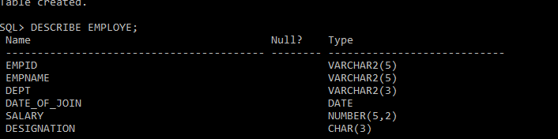

INSERT INTO EMPLOYE

SELECT *

FROM EMPOLY;

22. Display the contents of employee table



23. Delete all the records from employee table using dml command

DELETE FROM EMPOLY;

4 ROWS DELETED



24. Delete all the records from employee1 table using ddl command

TRUNCATE TABLE EMPLEEY;

25. Drop the table employee1

DROP TABLE EMPLEEY;

